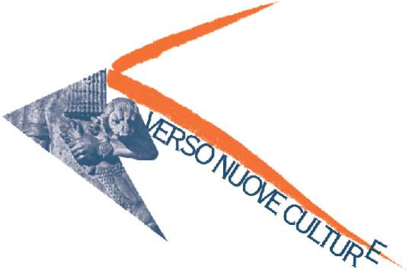
Dr. Luigi Cigolla, Assessor for Italian Culture of the Autonomous Province Bolzano-South Tyrol (Italy), presents:

Crossings between space and time:

“On the Way to New Cultures” arrives in Central Asia and Pakistan

The project “On the Way to New Cultures” reaches countries mythicized by the travel literature, geographical areas of great fascination along the old caravan routes.
“Crossings between space and time. Central Asia and Pakistan” is the title of the next initiative that enriches the already long list of manifestations forming this project, started in July 2001 by the provincial Department Italian Culture – Culture bureau of the Autonomous Province Bolzano-South Tyrol.
From February 19th till March 19th 2005 (opened every day from 10 a.m. to 6 p.m.; Thursday from 10 a.m. to 8 p.m.) at the Cultural Center Trevi, via Cappuccini in Bolzano, the exhibition “Pakistan and surroundings” with pictures of Massimiliano Fusari, the reportage “Pakistan Avenue. From Pakistan to South Tyrol” from Katia Bernardi about the Pakistan community in Bolzano and the conferences with experts will tell us the many similarities and the many differences in the geographical area between Central Asia and Pakistan.
The entrance is free.

The project “On the Way to New Cultures” was started in July 2001 by the provincial Department Italian Culture – Culture bureau; the project received from the beginning the patronage of the European Commission. The scientific consultant of “On the Way to New Cultures” is Mario Nordio from the University Ca’ Foscari in Venice.
Through exhibitions, conferences, performances, film revues, concerts, “On the Way to New Culture” presented till now South Africa, the Arabian world, Jewish culture, Iran, Russia. The intention is to present the most peculiar cultural and artistic aspects of “other” cultures, “new” because still less familiar to us, but ancient for history and civilisation and to investigate the signs of the “new cultures” that are taking shape in our present time.

Autonomous Province Bolzano-South Tyrol - Department Italian Culture – Culture bureau
Via del Ronco 2 – I-39100 BOLZANO
Info: Culture Bureau, tel. 0039 0471 411230
www.provincia.bz.it/cultura
CROSSINGS BETWEEN SPACE AND TIME. CENTRAL ASIA AND PAKISTAN
Cultural Center Trevi, via Cappuccini 28, Bolzano (Italy)
19.02-19.03.2005 every day from 10 a.m. to 6 p.m.; Thursday from 10 a.m. to 8 p.m.
Free entrance

Opening on Friday 18th February 2005, 6 p.m.
Vernissage of the photo exhibition and presentation of the reportage
Introducing conference by Mario Nordio, scientific consultant of “On the Way to New Cultures”:
“Well-known and mythicized Central Asia: travellers through the centuries”

Photo exhibition PAKISTAN AND SURROUNDINGS
Massimiliano Fusari, specialist in Iranian studies, M.A. in Media BSOAS, London
1. The Ashura Processions of Karachi (February-March 2003)
2. A Walk in Karachi (February-March 2003)
3. The Afghan Election in Iran (October 2004)
every day 10.00 a.m. - 6.00 p.m.; Thursday 10.00 a.m. – 8.00 p.m.

Reportage PAKISTAN AVENUE. FROM PAKISTAN TO SOUTH TYROL
Directed by Katia Bernardi
Première on Friday 25th February 2005, h. 8.30 p.m., cinema Eden
From 26th February at Cultural Center Trevi, every day in the morning at h. 10.00, 11.00 in the afternoon 3.00, 4.00, 5.00

CONFERENCES

Saturday, 19th February, h. 6.00 p.m.
The sound of nay “Musical traditions of Central Asia” – performance and guided listening
Giovanni De Zorzi (ethnomusicologist, Conservatory “C. Pollini”, Padova)

Friday 25th february, h. 8.30 p.m. at cinema Eden, via Leonardo da Vinci 8, Bolzano
FROM PAKISTAN TO SOUTH TYROL
“Pakistan Avenue. From Pakistan to South Tyrol”
Projection of Katia Bernardi’s reportage
“Pakistan from indipendence to nowadays”
Elisa Giunchi (Universities Statale and Bicocca – Milan) interwied by Paolo Mazzucato, RadioRAI, Bolzano
“The pakistan community in South Tyrol”
Jarral Pervez Akhtar, chairman Association Jinnah Pakistan, Bolzano

Friday 4th March, h. 8.30 p.m.
CENTRAL ASIA: CONTINUANCEAND DISCONTINUANCE
“Russians and Soviets in Central Asia”
Niccolò Pianciola (PhD Student, University of Napoli)
“Central asiatic answers to the russian presences”
Paolo Sartori (PhD student, University La Sapienza, Rome)
Conversation with the public, conduced by Mario Nordio, scientific consultant of “On the way to new cultures”

Friday 11th March, h. 8.30 p.m.
ISLAMIC ARCHITECTURES IN CENTRAL ASIA AND PAKISTAN
“Islamic architectures in Central Asia”
Giovanni Curatola (University of Udine)
“Pakistan placet of faith and holiness”
Diego Abenante (University of Trieste)

Friday 18th March, h. 8.30 p.m.
AROUND THE CENTER OF EUROASIATIC CONTINENT
“The central asiatic space from 19th century to the globalisation”
Aldo Ferrari (University Ca’ Foscari, Venice)
“Afghanistan: only a corridor?”
Giorgio Vercellin (University Ca’ Foscari, Venice)
Conversation with the public, conduced by Pietro Marangoni, daily Alto Adige, Bolzano

Saturday 19th March
h. 4.30 p.m.: “Afghan Tales” (in Italian and German)
Narrated by Margret Bergmann, Bolzano

h. 6.00 p.m.: guided listening “The young pakistan music”
Daniele Barina, musicologist, Bolzano

